**Decoding BMW’s Financial Health: A Comprehensive Analysis of Profit, Risk, and Growth.**

**🚀 Executive Summary**

* **Problem Statement**: The goal was to analyze BMW's financial performance across key areas of profitability, risk, leverage, and growth efficiency to understand how these factors have impacted the company’s overall performance from **2017 to 2024**.
* **Action Taken**: Using the BMW financial data, I performed an in-depth analysis of profitability, debt risk, asset utilization, and growth trends over time. The analysis was conducted through visualizations, KPIs, and ratios derived from the available data.
* **Result**: The analysis highlighted strong recovery in profitability and growth, despite some fluctuations in asset turnover and debt risk, showcasing a **59.09% increase in net income** and a **7.94% drop in revenue** from 2017 to 2024.

**Profitability Analysis**

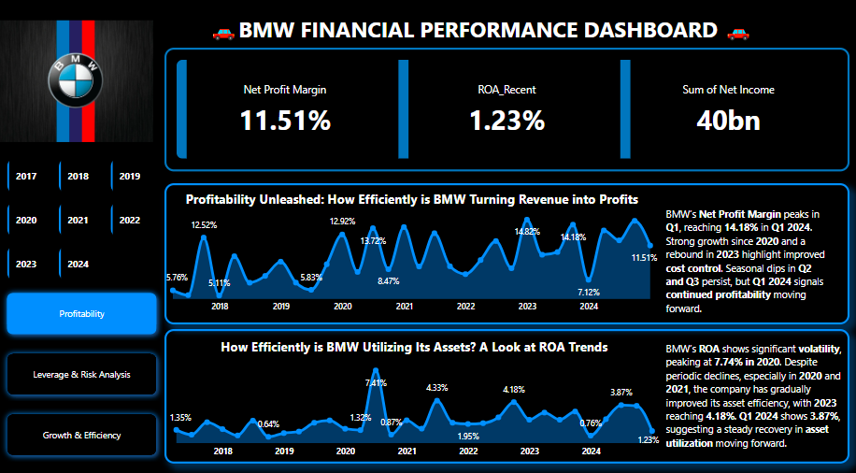

**Risk & Leverage Analysis**

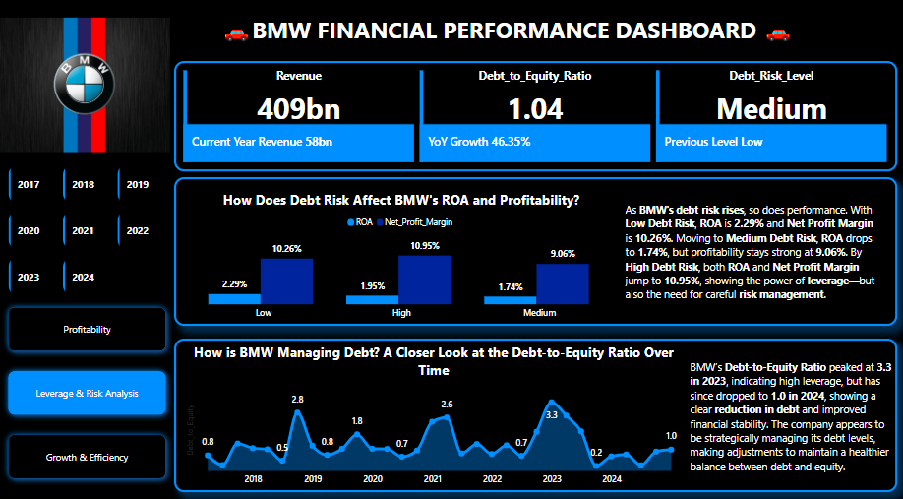

**Growth & Efficiency Analysis**

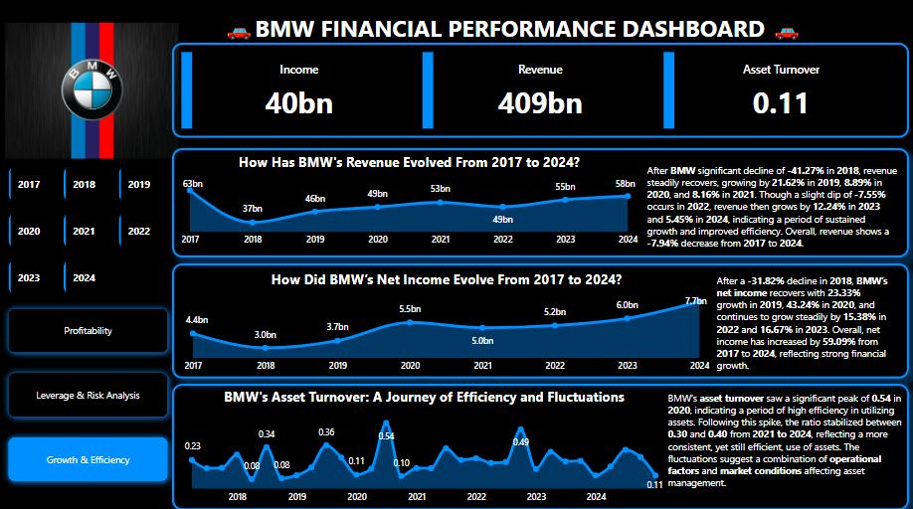

**🎯 Problem Statement**

* **Core Issue**: BMW needed to assess how effectively it is utilizing its assets and managing debt risk to sustain profitability and growth.
* **Key Questions**:
  1. How efficiently is BMW turning revenue into profit?
  2. How does debt risk influence profitability and asset turnover?
  3. What trends can be observed in asset utilization and efficiency?

**📈 Objectives & Key Metrics**

* **Business Objective**: To assess the efficiency of BMW’s asset utilization, profitability trends, and the impact of debt on the company’s overall financial health.
* **Key Metrics Tracked**:
  1. **Net Profit Margin**: Reflects how much of the revenue translates into profit.
  2. **ROA (Return on Assets)**: Measures how efficiently assets are used to generate profit.
  3. **Debt-to-Equity Ratio**: Evaluates BMW's financial leverage and risk.
  4. **Asset Turnover**: Indicates how effectively BMW is using its assets to generate revenue.
* **Result Achieved**:
  1. **Net Profit Margin** averaged **11.51%**.
  2. **ROA** increased to **1.23%** in 2024.
  3. **Revenue** decreased by **7.94%**, but net income grew by **59.09%** over the period.

**📂 Data Overview**

* **Data Sources**:
  1. Financial statements of BMW (public records and financial reports).
  2. Annual reports for key metrics (Net Income, ROA, Asset Turnover, Debt Ratio).
* **Key Variables**:
  1. **Revenue**
  2. **Net Income**
  3. **ROA**
  4. **Debt-to-Equity Ratio**
  5. **Asset Turnover**
* **Data Challenges**:
  1. **Missing quarterly data** for some years, especially related to asset turnover, which was estimated based on annual trends.
  2. Data consistency issues due to external market factors (pandemic impact on 2020 numbers).

**🔧 Methodology**

* **Data Cleaning**: Cleaned the data for missing values and standardized the presentation of all financial figures (e.g., converting all values into billions for consistency).
* **Analysis Techniques**:
  1. Descriptive statistics to summarize key financial metrics.
  2. Trend analysis for profitability, asset turnover, and debt management over time.
  3. Comparative analysis across debt risk levels (Low, Medium, High).
* **Tools**:
  1. **Power BI** for data visualization and dashboard creation.
  2. **Excel** for data cleaning and calculations.

**💡 Key Insights**

* **Insight 1: Profitability Unleashed**:
  + BMW’s **Net Profit Margin** peaked at **14.18%** in Q1 2024, reflecting a strong recovery in profitability after a dip in **2022** (7.12%).
  + The overall **average profit margin** stood at **11.51%**, showcasing solid profitability over the period.

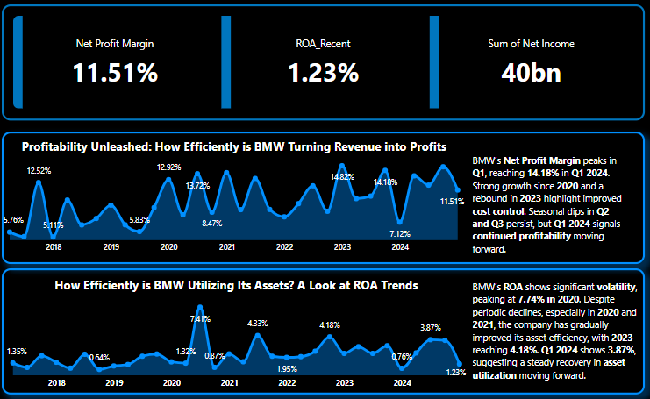

* **Insight 2: The Impact of Debt Risk**:
  + **Low Debt Risk** saw a **2.29% ROA** with a **10.26% Net Profit Margin**.
  + **Medium Debt Risk** resulted in a decrease in ROA to **1.74%** but a still robust **9.06% Net Profit Margin**.
  + The **High Debt Risk** scenario yielded an impressive **10.95% Net Profit Margin**, but ROA remained below optimal levels (**1.23%**), indicating a balance between leveraging debt and efficiency.

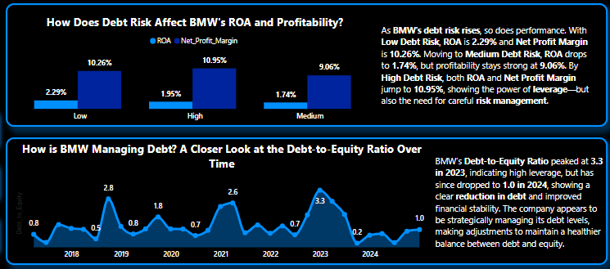

* **Insight 3: Asset Utilization Trends**:
  + Asset turnover peaked at **0.54** in **2020**, reflecting high asset utilization, but stabilized at **0.30-0.40** in the following years, showing consistent, though less efficient, asset use.

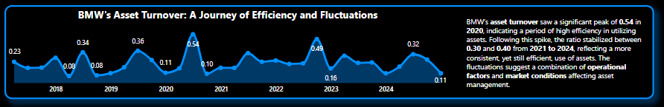

* **Insight 4: Revenue & Net Income Dynamics**:
  + Revenue showed a sharp **decline of 41.27%** in **2018**, followed by a steady recovery with a **7.94% overall decrease** from **2017 to 2024**.
  + Net income increased significantly by **59.09%**, indicating improved cost control and efficient profitability management.

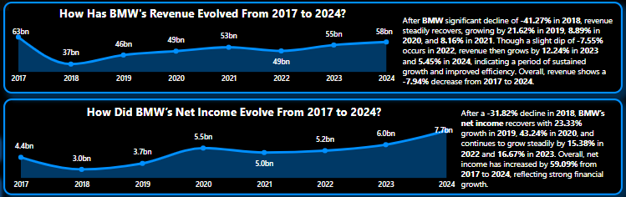

**✅ Recommendations & Business Impact**

* **Priority**: High
* **Recommendation**:
  1. Focus on improving **asset turnover** by investing in more efficient production or enhancing asset utilization across key departments.
  2. Maintain a balanced approach to **debt management**, ensuring leverage is optimally used for growth while keeping the **Debt-to-Equity Ratio** within sustainable limits.
* **Expected Impact**:
  1. Improved **asset turnover** could lead to a **5-10% increase in revenue**.
  2. Effective **debt management** could enhance profitability and reduce the risks associated with financial leverage.
* **BMW Team**:
  1. **Finance Department**: Oversee debt management and profitability improvement.
  2. **Operations Team**: Enhance asset utilization and productivity.

**📉 Caveats & Next Steps**

* **Limitations**:
  1. The data for **2020** and **2021** showed large fluctuations due to external factors like the pandemic, affecting comparability.
  2. Some internal data for quarterly asset turnover was missing.
* **Next Steps**:
  1. Establish **improved data collection practices** to ensure more accurate quarterly tracking of key metrics.
  2. Further investigate the **impact of external market conditions** on profitability and asset turnover, particularly in the years following the pandemic.